James Hahn

STAT1221

Homework #7

MINITAB Output

**Chapter 13**

13b + 13c)

Regression Analysis: SPY versus SPX, Z1, Z2

Method

|  |  |
| --- | --- |
| Categorical predictor coding | (1, 0) |

Analysis of Variance

|  |  |  |  |  |  |
| --- | --- | --- | --- | --- | --- |
| Source | DF | Adj SS | Adj MS | F-Value | P-Value |
| Regression | 5 | 219.943 | 43.989 | 2.25 | 0.137 |
| SPX | 1 | 6.754 | 6.754 | 0.35 | 0.571 |
| Z1 | 1 | 42.260 | 42.260 | 2.16 | 0.175 |
| Z2 | 1 | 37.966 | 37.966 | 1.94 | 0.197 |
| SPX*Z1 | 1 | 32.533 | 32.533 | 1.67 | 0.229 |
| SPX*Z2 | 1 | 33.864 | 33.864 | 1.73 | 0.220 |
| Error | 9 | 175.790 | 19.532 |  |  |
| Total | 14 | 395.733 |  |  |  |

Model Summary

|  |  |  |  |
| --- | --- | --- | --- |
| S | R-sq | R-sq(adj) | R-sq(pred) |
| 4.41953 | 55.58% | 30.90% | 3.27% |

Coefficients

|  |  |  |  |  |  |
| --- | --- | --- | --- | --- | --- |
| Term | Coef | SE Coef | T-Value | P-Value | VIF |
| Constant | 31.9 | 24.4 | 1.31 | 0.224 |  |
| SPX | -0.407 | 0.692 | -0.59 | 0.571 | 16.31 |
| Z1 |  |  |  |  |  |
| 1 | -40.0 | 27.2 | -1.47 | 0.175 | 125.97 |
| Z2 |  |  |  |  |  |
| 1 | -36.3 | 26.0 | -1.39 | 0.197 | 115.66 |
| SPX*Z1 |  |  |  |  |  |
| 1 | 0.980 | 0.759 | 1.29 | 0.229 | 143.57 |
| SPX*Z2 |  |  |  |  |  |
| 1 | 0.998 | 0.758 | 1.32 | 0.220 | 85.03 |

Regression Equation

|  |  |  |  |  |
| --- | --- | --- | --- | --- |
| Z1 | Z2 |  |  |  |
| 0 | 0 | SPY | = | 31.9 - 0.407 SPX |
|  |  |  |  |  |
| 0 | 1 | SPY | = | -4.37 + 0.591 SPX |
|  |  |  |  |  |
| 1 | 0 | SPY | = | -8.0 + 0.573 SPX |
|  |  |  |  |  |
| 1 | 1 | SPY | = | -44.3 + 1.571 SPX |
|  |  |  |  |  |

Regression Analysis: SPY versus SPX, Z1, Z2

Method

|  |  |
| --- | --- |
| Categorical predictor coding | (1, 0) |

Analysis of Variance

|  |  |  |  |  |  |
| --- | --- | --- | --- | --- | --- |
| Source | DF | Adj SS | Adj MS | F-Value | P-Value |
| Regression | 3 | 183.666 | 61.222 | 3.18 | 0.067 |
| SPX | 1 | 107.532 | 107.532 | 5.58 | 0.038 |
| Z1 | 1 | 67.883 | 67.883 | 3.52 | 0.087 |
| Z2 | 1 | 6.852 | 6.852 | 0.36 | 0.563 |
| Error | 11 | 212.068 | 19.279 |  |  |
| Total | 14 | 395.733 |  |  |  |

Model Summary

|  |  |  |  |
| --- | --- | --- | --- |
| S | R-sq | R-sq(adj) | R-sq(pred) |
| 4.39077 | 46.41% | 31.80% | 5.96% |

Coefficients

|  |  |  |  |  |  |
| --- | --- | --- | --- | --- | --- |
| Term | Coef | SE Coef | T-Value | P-Value | VIF |
| Constant | 0.30 | 7.58 | 0.04 | 0.969 |  |
| SPX | 0.491 | 0.208 | 2.36 | 0.038 | 1.49 |
| Z1 |  |  |  |  |  |
| 1 | -5.28 | 2.81 | -1.88 | 0.087 | 1.37 |
| Z2 |  |  |  |  |  |
| 1 | -1.86 | 3.12 | -0.60 | 0.563 | 1.68 |

Regression Equation

|  |  |  |  |  |
| --- | --- | --- | --- | --- |
| Z1 | Z2 |  |  |  |
| 0 | 0 | SPY | = | 0.30 + 0.491 SPX |
|  |  |  |  |  |
| 0 | 1 | SPY | = | -1.56 + 0.491 SPX |
|  |  |  |  |  |
| 1 | 0 | SPY | = | -4.98 + 0.491 SPX |
|  |  |  |  |  |
| 1 | 1 | SPY | = | -6.84 + 0.491 SPX |
|  |  |  |  |  |

Regression Analysis: SPY versus SPX

Analysis of Variance

|  |  |  |  |  |  |
| --- | --- | --- | --- | --- | --- |
| Source | DF | Adj SS | Adj MS | F-Value | P-Value |
| Regression | 1 | 115.60 | 115.60 | 5.36 | 0.038 |
| SPX | 1 | 115.60 | 115.60 | 5.36 | 0.038 |
| Error | 13 | 280.13 | 21.55 |  |  |
| Lack-of-Fit | 11 | 255.13 | 23.19 | 1.86 | 0.402 |
| Pure Error | 2 | 25.00 | 12.50 |  |  |
| Total | 14 | 395.73 |  |  |  |

Model Summary

|  |  |  |  |
| --- | --- | --- | --- |
| S | R-sq | R-sq(adj) | R-sq(pred) |
| 4.64204 | 29.21% | 23.77% | 4.70% |

Coefficients

|  |  |  |  |  |  |
| --- | --- | --- | --- | --- | --- |
| Term | Coef | SE Coef | T-Value | P-Value | VIF |
| Constant | 0.43 | 6.18 | 0.07 | 0.945 |  |
| SPX | 0.417 | 0.180 | 2.32 | 0.038 | 1.00 |

Regression Equation

|  |  |  |
| --- | --- | --- |
| SPY | = | 0.43 + 0.417 SPX |

**Chapter 14**

1a)



1b)

https://i.gyazo.com/8dc642ecce597152bc62da9153711bbf.png



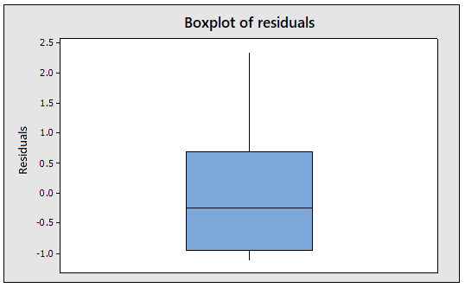



1c)

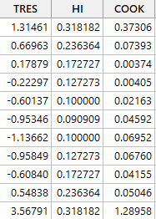

2a)



2b)

https://gyazo.com/078173b2a497034d2dc90022b952ac41.png



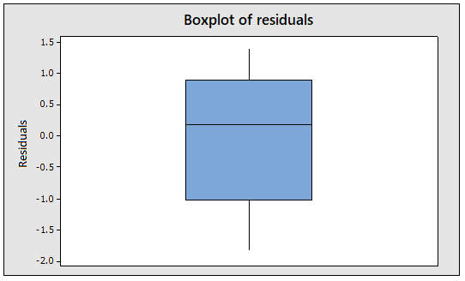

2c)

